Oblique Pentagonal Pyramid
# Source: AI Source: Provided by: [Data Path: Persons Table -> ID Column: 1, Name_En Column: Motasem Essam] -> From: [ChatGPT] on [7/25/2026]
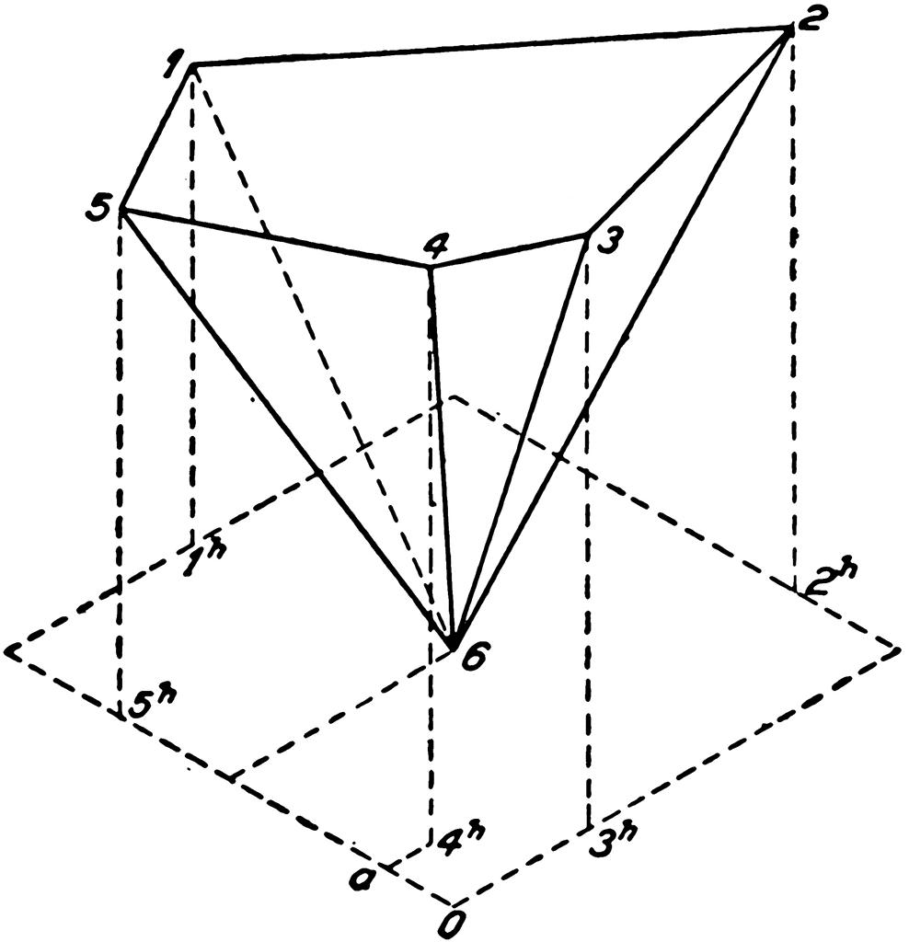

Definition
# Source: AI Source: Provided by: [Data Path: Persons Table -> ID Column: 1, Name_En Column: Motasem Essam] -> From: [ChatGPT] on [7/25/2026]
An oblique pentagonal pyramid is a three-dimensional geometric solid with a pentagonal base and five triangular lateral faces that meet at a single point called the apex. The apex is positioned away from the designated center of the base, so the pyramid is inclined rather than right.
Its lateral edges generally have different lengths, and its lateral faces are not necessarily congruent. The perpendicular height is the shortest distance from the apex to the plane containing the base; it is not the length of a sloping lateral edge.

Simple Definition
# Source: AI Source: Provided by: [Data Path: Persons Table -> ID Column: 1, Name_En Column: Motasem Essam] -> From: [ChatGPT] on [7/25/2026]
An oblique pentagonal pyramid is a five-sided pyramid whose apex is not directly above the center of its base, giving the solid a slanted appearance.

Key Characteristics
# Source: AI Source: Provided by: [Data Path: Persons Table -> ID Column: 1, Name_En Column: Motasem Essam] -> From: [ChatGPT] on [7/25/2026]
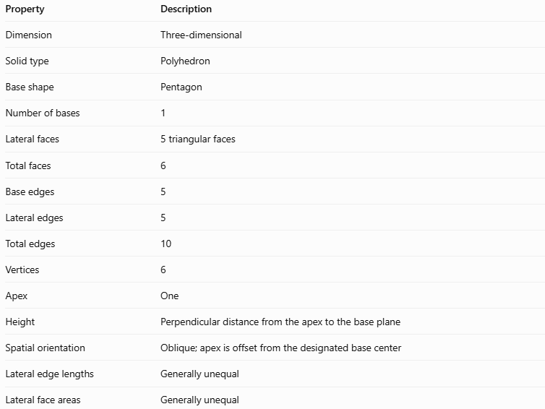
Property | Description
Dimension | Three-dimensional
Solid type | Polyhedron
Base shape | Pentagon
Number of bases | 1
Lateral faces | 5 triangular faces
Total faces | 6
Base edges | 5
Lateral edges | 5
Total edges | 10
Vertices | 6
Apex | One
Height | Perpendicular distance from the apex to the base plane
Spatial orientation | Oblique; apex is offset from the designated base center
Lateral edge lengths | Generally unequal
Lateral face areas | Generally unequal
An oblique pyramid may have a regular or irregular pentagonal base. The term oblique describes the position of the apex relative to the base, not whether the base polygon is regular.

Geometric Representation
# Source: AI Source: Provided by: [Data Path: Persons Table -> ID Column: 1, Name_En Column: Motasem Essam] -> From: [ChatGPT] on [7/25/2026]
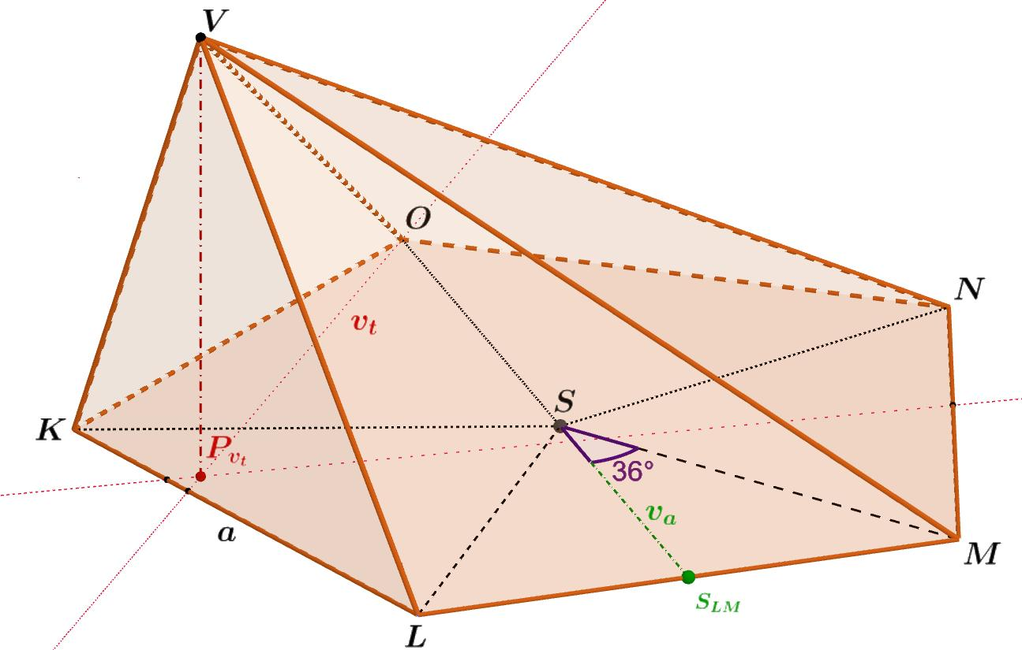
The main components are:
- Pentagonal base: The five-sided polygon forming the bottom of the pyramid.
- Apex: The point where the five triangular lateral faces meet.
- Base edges: The five sides of the pentagonal base.
- Lateral edges: The five sloping line segments connecting the apex to the base vertices.
- Lateral faces: The five triangular faces connecting the apex to each base edge.
- Perpendicular height ($h$): The perpendicular distance from the apex to the plane of the base.
- Foot of the height: The point where the perpendicular height meets the base plane. For an oblique pyramid, this point is generally not the designated center of the base.
- Slant height: Unlike a regular right pyramid, an oblique pyramid generally has no single common slant height for all its lateral faces. Each triangular face may have a different altitude.

Mathematical Representations and Formulas
# Source: AI Source: Provided by: [Data Path: Persons Table -> ID Column: 1, Name_En Column: Motasem Essam] -> From: [ChatGPT] on [7/25/2026]
Let:
- $B$ = area of the pentagonal base
- $h$ = perpendicular height
- $p$ = perimeter of the base
- $A_{i}$ = area of the $i$-th lateral triangular face
- $s_{i}$ = length of the $i$-th base edge
- $l_{i}$ = altitude of the $i$-th lateral triangular face, measured perpendicular to its base edge

A. Base perimeter
# Source: AI Source: Provided by: [Data Path: Persons Table -> ID Column: 1, Name_En Column: Motasem Essam] -> From: [ChatGPT] on [7/25/2026]
For a pentagon with side lengths $s_{1},s_{2},s_{3},s_{4},s_{5}$,
$$p=s_{1}+s_{2}+s_{3}+s_{4}+s_{5}$$

B. Base area
# Source: AI Source: Provided by: [Data Path: Persons Table -> ID Column: 1, Name_En Column: Motasem Essam] -> From: [ChatGPT] on [7/25/2026]
The area of the pentagonal base depends on its shape. For an irregular pentagon, it can be calculated by dividing it into three triangles and adding their areas:
$$B=A_{1}+A_{2}+A_{3}$$
Here, the triangle areas refer to the decomposition of the base, not the lateral faces.

C. Volume
# Source: AI Source: Provided by: [Data Path: Persons Table -> ID Column: 1, Name_En Column: Motasem Essam] -> From: [ChatGPT] on [7/25/2026]
The volume formula is the same for right and oblique pyramids:
$$\boxed{V=\frac{1}{3}Bh}$$
The height $h$ must be perpendicular to the base plane, not measured along a sloping edge.

D. Lateral surface area
# Source: AI Source: Provided by: [Data Path: Persons Table -> ID Column: 1, Name_En Column: Motasem Essam] -> From: [ChatGPT] on [7/25/2026]
The lateral surface area is the sum of the areas of all five triangular faces:
$$A_{L}=\sum_{i=1}^{5}{A_{i}}$$
Because the area of each triangle is half its base times its perpendicular altitude,
$$\boxed{A_{L}=\frac{1}{2}\sum_{i=1}^{5}{s_{i}}l_{i}}$$
In general, you cannot use \(A_L=\frac12p\ell\) with one common slant height for an oblique pentagonal pyramid.

E. Total surface area
# Source: AI Source: Provided by: [Data Path: Persons Table -> ID Column: 1, Name_En Column: Motasem Essam] -> From: [ChatGPT] on [7/25/2026]
$$\boxed{A_{T}=B+A_{L}}$$
This includes the pentagonal base and all five lateral faces.

F. Euler's formula
# Source: AI Source: Provided by: [Data Path: Persons Table -> ID Column: 1, Name_En Column: Motasem Essam] -> From: [ChatGPT] on [7/25/2026]
For a convex pentagonal pyramid:
$$V_{e}-E+F=2$$
$$6-10+6=2$$
where $V_{e}$ is the number of vertices, $E$ the number of edges, and $F$ the number of faces.

Worked Examples
# Source: AI Source: Provided by: [Data Path: Persons Table -> ID Column: 1, Name_En Column: Motasem Essam] -> From: [ChatGPT] on [7/25/2026]
Example 1: Counting faces, edges, and vertices
An oblique pentagonal pyramid has a five-sided base.
- Faces: $5+1=6$
- Edges: $5+5=10$
- Vertices: $5+1=6$
The inclination of the pyramid changes its shape, but not these counts.
Example 2: Calculating volume
Suppose an oblique pentagonal pyramid has a base area of $42{\text{ cm}}^{2}$ and a perpendicular height of $9\text{ cm}$.
$$V=\frac{1}{3}Bh$$
$$V=\frac{1}{3}\left(42\right)\left(9\right)$$
$$\boxed{V=126{\text{ cm}}^{3}}$$
Even though the apex is offset, the volume formula remains unchanged.
Example 3: Calculating lateral and total surface area
Suppose the five triangular lateral faces have the following areas:
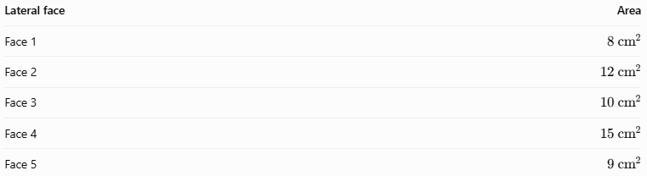
Lateral face | Area
Face 1 | $$8{\text{ cm}}^{2}$$
Face 2 | $$12{\text{ cm}}^{2}$$
Face 3 | $$10{\text{ cm}}^{2}$$
Face 4 | $$15{\text{ cm}}^{2}$$
Face 5 | $$9{\text{ cm}}^{2}$$
The lateral surface area is:
$$A_{L}=8+12+10+15+9$$
$$\boxed{A_{L}=54{\text{ cm}}^{2}}$$
If the base area is $42{\text{ cm}}^{2}$, then:
$$A_{T}=B+A_{L}$$
$$A_{T}=42+54$$
$$\boxed{A_{T}=96{\text{ cm}}^{2}}$$

Comparison with Related Concepts
# Source: AI Source: Provided by: [Data Path: Persons Table -> ID Column: 1, Name_En Column: Motasem Essam] -> From: [ChatGPT] on [7/25/2026]
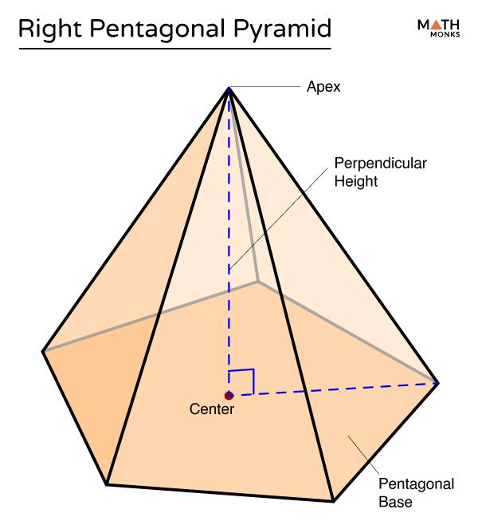
Right Pentagonal Pyramid
Its apex lies directly above the designated center of the base. The perpendicular height meets the base at that center.
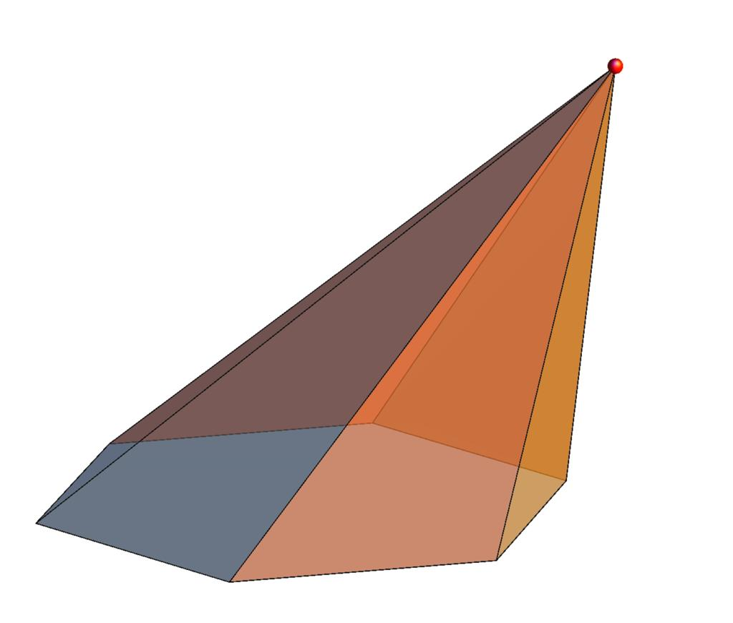
Oblique Pentagonal Pyramid
Its apex is offset from the designated base center. The lateral edges and face areas are generally unequal.
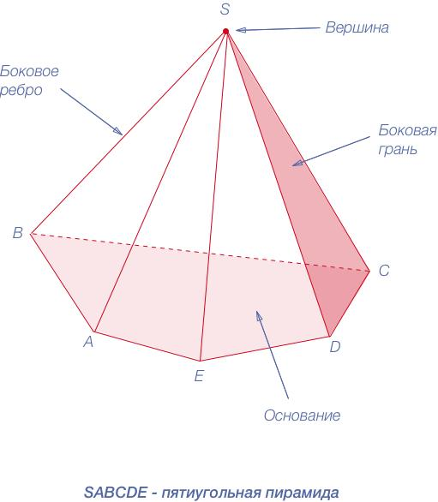
Regular Pentagonal Pyramid
It has a regular pentagonal base and an apex directly above its center. Its five lateral faces are congruent isosceles triangles.
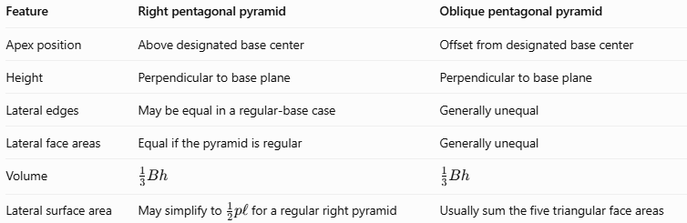
Feature | Right pentagonal pyramid | Oblique pentagonal pyramid
Apex position | Above designated base center | Offset from designated base center
Height | Perpendicular to base plane | Perpendicular to base plane
Lateral edges | May be equal in a regular-base case | Generally unequal
Lateral face areas | Equal if the pyramid is regular | Generally unequal
Volume | $$\frac{1}{3}Bh$$ | $$\frac{1}{3}Bh$$
Lateral surface area | May simplify to $\frac{1}{2}pl$ for a regular right pyramid | Usually sum the five triangular face areas

Applications
# Source: AI Source: Provided by: [Data Path: Persons Table -> ID Column: 1, Name_En Column: Motasem Essam] -> From: [ChatGPT] on [7/25/2026]
- Architecture: Designing inclined roofs and decorative structures with polygonal bases.
- Product design: Creating asymmetrical packaging and display models.
- Computer graphics: Modeling tilted polygonal solids in 3D environments.
- Engineering: Estimating the surface area and volume of inclined components.
- Geometry education: Demonstrating that the volume of a pyramid depends on base area and perpendicular height rather than the position of its apex alone.

Key Points
# Source: AI Source: Provided by: [Data Path: Persons Table -> ID Column: 1, Name_En Column: Motasem Essam] -> From: [ChatGPT] on [7/25/2026]
- An oblique pentagonal pyramid has 6 faces, 10 edges, and 6 vertices.
- It consists of one pentagonal base and five triangular lateral faces.
- Its apex is offset from the designated center of the base.
- Its height is always measured perpendicular to the base plane.
- The lateral edges and triangular face areas are generally unequal.
- Its volume is $V=\frac{1}{3}Bh$.
- Its lateral surface area is calculated by adding the areas of the five triangular faces.
- Oblique describes spatial orientation, while regular or irregular describes the base shape.

Conclusion
# Source: AI Source: Provided by: [Data Path: Persons Table -> ID Column: 1, Name_En Column: Motasem Essam] -> From: [ChatGPT] on [7/25/2026]
An oblique pentagonal pyramid is a five-sided pyramid whose apex is positioned away from the designated center of its base. Although its inclined shape can make surface-area calculations more involved, its face, edge, and vertex counts remain the same as those of a right pentagonal pyramid. The essential principles are to measure height perpendicularly, calculate each lateral face when necessary, and distinguish the pyramid's orientation from the regularity of its base.

